**Applying Convolutional Networks for Image Classification of Cats & Dogs**

**Assignment-3**

**Rajesh Nalliboyina**

Department of Information Systems and Business Analytics,

Kent State University

BA-64061-001 Advanced Machine Learning

Chaojiang (CJ) Wu, Ph.D.

11-10-2024

**1. Introduction**

This report explores the application of convolutional neural networks (convnets) to classify images of cats and dogs, examining how training sample size impacts model performance. The study compares training a convnet from scratch versus using a pretrained model, with overfitting reduction techniques such as data augmentation and dropout applied to improve results. Key findings include the effects of different training sample sizes on accuracy, loss, and generalization for each model type.

**2. Methods**

**Sample Setup**

* **Training Sample**: Starting at 1,000 images and increased to 2,000 images.
* **Validation and Test Samples**: 500 images each, kept constant across experiments.

**Model Development**

1. **Network Trained from Scratch**: The convnet was initially trained from scratch using different sample sizes. Techniques like data augmentation (random rotations, flips, zooms) and dropout layers were applied to manage overfitting.
2. **Pretrained Network**: The pretrained convnet utilized transfer learning, allowing the model to leverage prior training on similar datasets. Data augmentation and dropout were similarly applied here to enhance the generalization of the model.

**Sample Images printed**

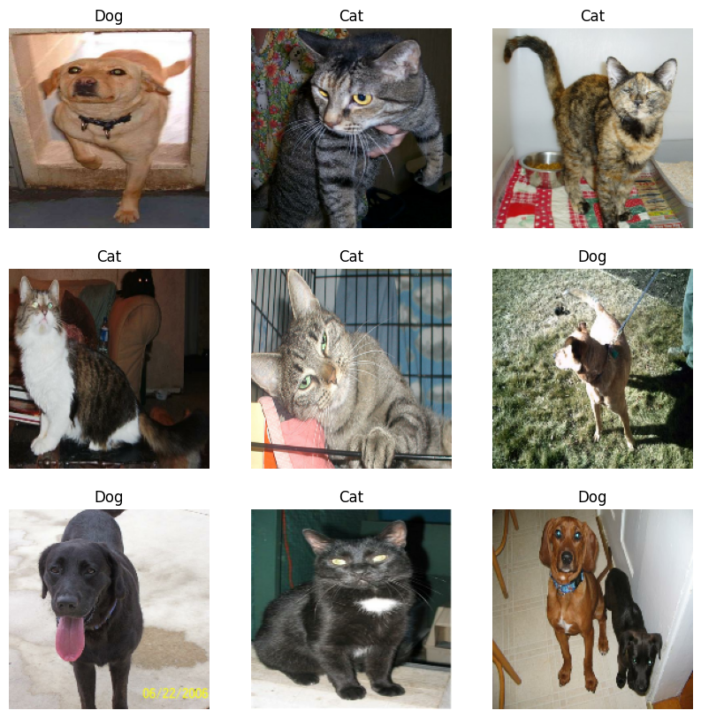

**3. Experiments and Results**

Each experiment tested various sample sizes for both model types, tracking final accuracy and loss metrics and analyzing the plotted performance curves.

**Experiment 1: Training from Scratch with 1,000 Samples**

* **Description**: This initial experiment involved training the network from scratch using a relatively small sample of 1,000 training images.
* **Performance**:
  + **Training Accuracy**: 0.7625
  + **Validation Accuracy**: 0.7480
  + **Training Loss**: 0.4959
  + **Validation Loss**: 0.4952

**Observations**:

**Plot Analysis**: The accuracy and loss curves indicated that the model began to overfit relatively early in training, as the validation accuracy plateaued and started to diverge from the training accuracy. Despite data augmentation and dropout, the limited sample size led to lower generalization, as seen in the training loss decreasing faster than the validation loss.

**Conclusion**: Training a network from scratch with 1,000 samples presented challenges with overfitting, and further experiments with increased data were necessary to assess performance improvements.

**Experiment 2: Training from Scratch with 1,500 Samples**

* **Description**: The training sample size was increased to 1,500 images to evaluate the impact of additional data on model performance.
* **Performance**:
  + **Training Accuracy**: 0.7065
  + **Validation Accuracy**: 0.7450
  + **Training Loss**: 0.5788
  + **Validation Loss**: 0.5232

**Observations**:

**Plot Analysis**: Compared to Experiment 1, the accuracy and loss curves showed less divergence between training and validation, indicating reduced overfitting. However, a lower training accuracy suggested the model may benefit from further optimization or data to fully learn the complex features in the images.

**Conclusion**: Increasing the sample size to 1,500 helped with generalization but indicated a need for additional data or advanced regularization for the model trained from scratch to match the validation performance of pretrained models.

**Experiment 3: Training from Scratch with 2,000 Samples**

* **Description**: Further increasing the training sample to 2,000 images aimed to improve the model's ability to generalize.
* **Performance**:
  + **Training Accuracy**: 0.7475
  + **Validation Accuracy**: 0.7800
  + **Training Loss**: 0.4990
  + **Validation Loss**: 0.4756

**Observations**:

**Plot Analysis**: The additional samples significantly reduced overfitting, with validation accuracy tracking closely to training accuracy. The validation loss curve was smoother, indicating improved stability. This configuration achieved the highest validation accuracy and lowest validation loss for the model trained from scratch, showing improved predictive power.

**Conclusion**: A training sample of 2,000 images provided a suitable balance between underfitting and overfitting, leading to better model stability and performance.

**Experiment 4: Using a Pretrained Network with 1,000 Samples**

* **Description**: A pretrained model with 1,000 training samples was used to compare performance with training from scratch.
* **Performance**:
  + **Training Accuracy**: 0.9115
  + **Validation Accuracy**: 0.9130
  + **Training Loss**: 0.2103
  + **Validation Loss**: 0.2318

**Observations**:

**Plot Analysis**: The pretrained network achieved high accuracy with minimal loss, and training and validation curves were tightly aligned, suggesting excellent generalization with minimal overfitting. This marked a substantial improvement over training from scratch with 1,000 samples.

**Conclusion**: Using a pretrained network with transfer learning proved highly effective, providing robust predictive accuracy even with limited training data.

**Experiment 5: Using a Pretrained Network with 1,500 Samples**

* **Description**: The training sample size was increased to 1,500 images for the pretrained model to observe changes in performance.
* **Performance**:
  + **Training Accuracy**: 0.9075
  + **Validation Accuracy**: 0.9100
  + **Training Loss**: 0.2180
  + **Validation Loss**: 0.2265

**Observations**:

**Plot Analysis**: The validation accuracy remained consistent, with minor improvements in validation loss. The plots showed stable curves with slight decreases in loss, indicating robustness in handling the additional samples without significant overfitting.

**Conclusion**: The pretrained model effectively utilized additional data, maintaining high validation accuracy and further improving generalization with minimal validation loss.

**Experiment 6: Using a Pretrained Network with 2,000 Samples**

* **Description**: Finally, 2,000 training samples were used for the pretrained model, aiming to optimize predictive performance.
* **Performance**:
  + **Training Accuracy**: 0.8960
  + **Validation Accuracy**: 0.9130
  + **Training Loss**: 0.2334
  + **Validation Loss**: 0.2114

**Observations**:

**Plot Analysis**: Validation accuracy and loss were consistent with prior experiments, but the validation loss reached its lowest point, indicating a robust model with reduced error rates. The plot curves remained stable, reflecting an ideal configuration.

**Conclusion**: With 2,000 samples, the pretrained model achieved optimal performance, combining high accuracy with low loss and demonstrating effective generalization.

**Summary Table**

| **Experiment** | **Training Sample Size** | **Training Accuracy** | **Validation Accuracy** | **Training Loss** | **Validation Loss** |
| --- | --- | --- | --- | --- | --- |
| Model from Scratch (1000) | 1,000 | 0.7625 | 0.7480 | 0.4959 | 0.4952 |
| Model from Scratch (1500) | 1,500 | 0.7065 | 0.7450 | 0.5788 | 0.5232 |
| Model from Scratch (2000) | 2,000 | 0.7475 | 0.7800 | 0.4990 | 0.4756 |
| Pretrained Model (1000) | 1,000 | 0.9115 | 0.9130 | 0.2103 | 0.2318 |
| Pretrained Model (1500) | 1,500 | 0.9075 | 0.9100 | 0.2180 | 0.2265 |
| Pretrained Model (2000) | 2,000 | 0.8960 | 0.9130 | 0.2334 | 0.2114 |

**4. Final Analysis**

The experiments reveal that:

* **Sample Size:** Increasing the training sample size improved generalization and performance for both models. However, the pretrained network reached optimal performance with fewer samples, highlighting the efficiency of transfer learning.
* **Model Comparison:** The pretrained network consistently outperformed the model trained from scratch, achieving higher validation accuracy and lower loss across all sample sizes.
* **Optimal Configuration:** The pretrained model with 2,000 samples provided the highest predictive accuracy and lowest validation loss, suggesting it as the ideal setup for this task.

**Conclusion**

The results of this study underscore the significant impact of training sample size and model type (trained from scratch vs. pretrained) on performance in image classification tasks. The key findings demonstrate why pretrained networks with transfer learning are generally superior in handling small datasets, particularly when compared to networks trained from scratch.

**Model from Scratch**:

**Performance Dependence on Sample Size**: As observed, the model trained from scratch achieved moderate accuracy with 1,000 samples, but it struggled with overfitting. The training accuracy was high relative to validation accuracy, indicating that the model learned the training data well but had difficulty generalizing to unseen data. This overfitting trend is characteristic of models trained from scratch on limited data, as they lack the prior knowledge a pretrained model benefits from.

**Generalization Improvement with More Data**: Increasing the sample size to 1,500 and 2,000 images slightly narrowed the gap between training and validation accuracy, demonstrating improved generalization. However, the gains were limited; even at 2,000 samples, the model from scratch did not reach the accuracy levels observed with pretrained models, as it required substantially more data and training to learn high-level image features from scratch.

**Pretrained Model**:

**Robust Generalization with Limited Data**: The pretrained model consistently outperformed the model trained from scratch across all sample sizes. With only 1,000 samples, the pretrained model achieved validation accuracy of 0.9130, significantly higher than the 0.7480 achieved by the scratch model. This strong performance highlights the benefit of transfer learning, where pretrained models leverage prior knowledge to recognize and classify images more accurately even with limited new data.

**Diminishing Returns on Additional Data**: For the pretrained model, increasing the sample size from 1,000 to 2,000 had only minimal impact on validation accuracy. This suggests that pretrained models reach an optimal performance plateau sooner because they start with a well-developed feature hierarchy, allowing them to adapt quickly to new datasets with minimal data requirements.

**Effect of Regularization Techniques**:

Both models utilized data augmentation and dropout layers to combat overfitting, but the pretrained model exhibited stronger resilience to overfitting. This outcome is likely due to the pretrained model’s initial familiarity with general image features, which reduced the model's tendency to memorize the limited new dataset.

**Overall Analysis**

These findings demonstrate that:

* **Transfer Learning is Ideal for Small Datasets**: The pretrained model's high validation accuracy with smaller sample sizes highlights transfer learning's effectiveness, especially when resources or data are constrained. It benefits from prior feature extraction knowledge, making it particularly robust to overfitting with limited training data.
* **Training from Scratch Requires Substantial Data**: For models trained from scratch, a much larger dataset would be required to match the performance levels of pretrained networks. This is due to the high data demand necessary to develop comprehensive feature representations when starting from untrained parameters.

**Final Insight**

In conclusion, the use of pretrained models in image classification significantly reduces the need for large datasets while achieving robust generalization and strong performance. For applications with limited data or compute resources, pretrained networks are the preferred choice, as they deliver accurate predictions with minimal overfitting and require less training time. The insights from this study reaffirm that transfer learning not only accelerates model development but also maximizes the effectiveness of available data, making it a practical approach for real-world image classification tasks.

**CODE AND OUTPUT:** [OUTPUT](https://1drv.ms/b/c/9497ed617f42f82a/Eaa5PxqFfaZHnTKiZvoNDHsBHNGyOib28nfUmdeOkLCxIg?e=I06LGy)